**BUILD AN EVENT MANAGEMENT SYSTEM USING SALESFORCE**

**PROJECT REPORT TEMPLATE**

INTRODUCTION:

**Even management is the process of creating and maintaining an event. This process spans from the very beginning of planning all the way to post-event strategizing.**

**All different branches of planning go into event management, including various types of sourcing, designing, regulation checks, and onsite management. In event management, you could be in the process of creating a conference, a product launch, an internal sale kick-off or even a wedding.**

**Event management is the process of creating and maintaining an event. This process spans from the very beginning of planning all the way to post-event strategizing. At the start, an event manager makes planning decisions, such as the time, location and theme of the event.**

**EMPATHY MAP**

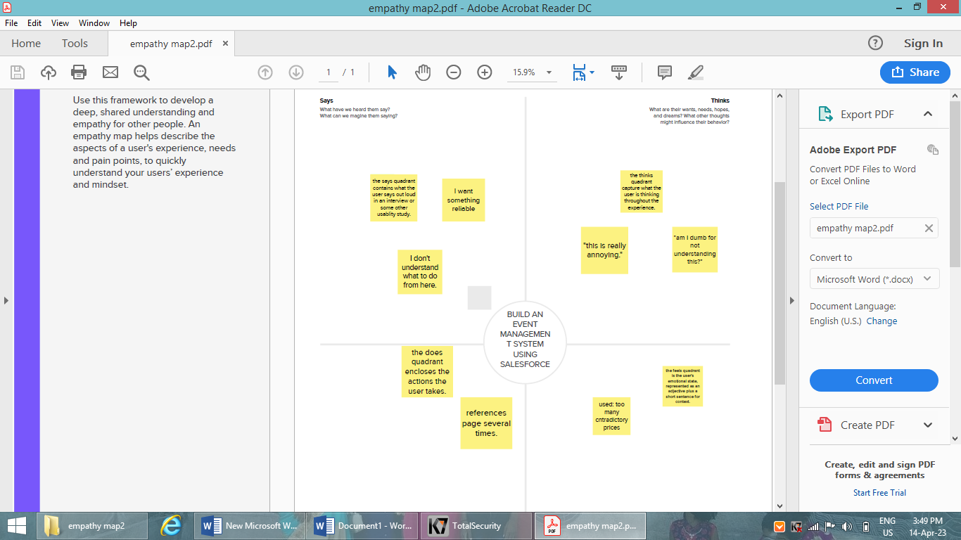

**BRAINS TORM**

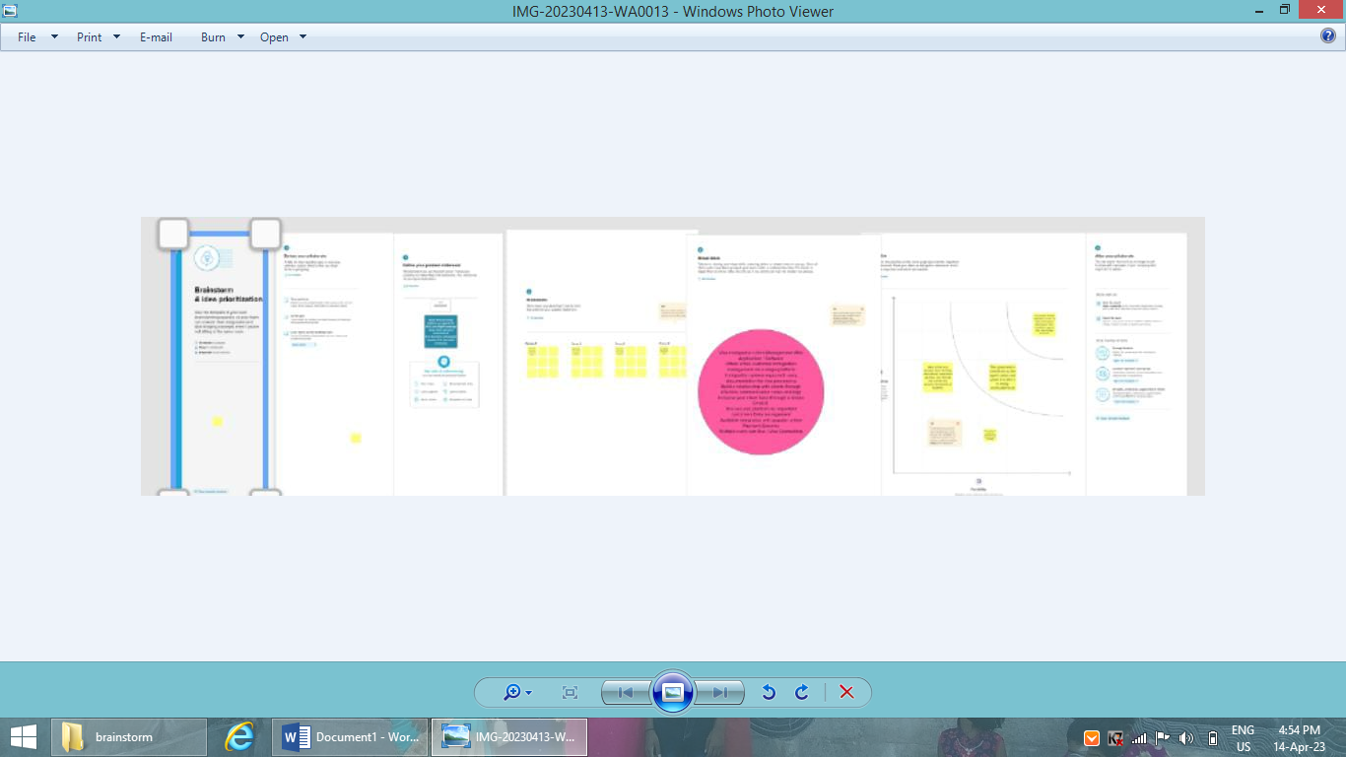

**RESULT**

|  |  |
| --- | --- |
| **Object name** | **Fields in the object** |
| **Object 1** | **Field label: City**  **Data type: Text** |
| **Object 2** | **Field label: Start date**  **Data type: Date/time** |
| **Object 3** | **Field label: Id**  **Data type: Auto number** |
| **Object 4** | **Field label: Phone**  **Data** **type:** **Phone** |
| **Object 5** | **Field label: Email**  **Data type: Email** |

ACTIVITY:

Creation of fields for the event object:

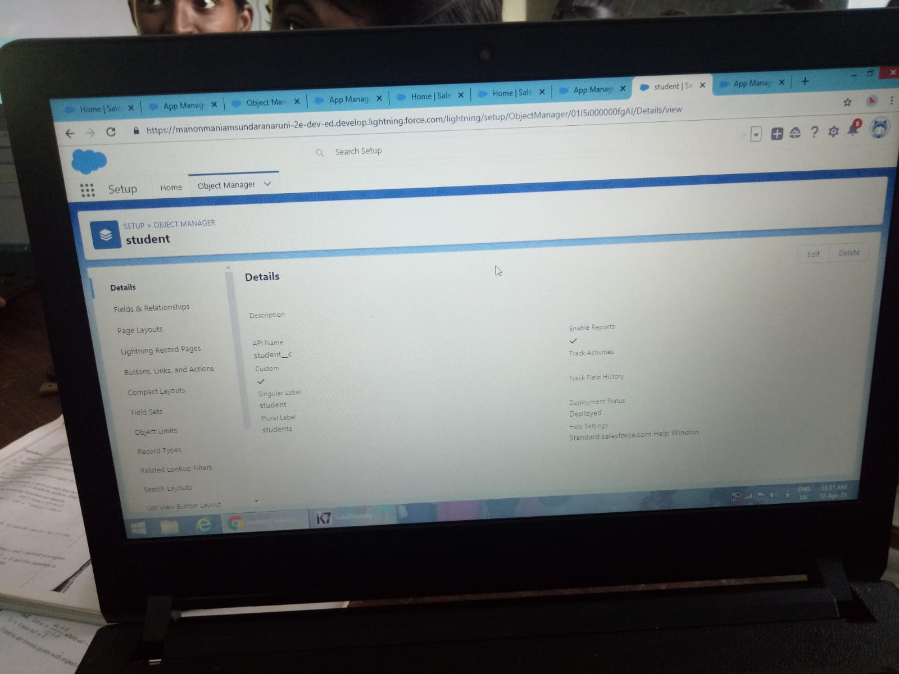

Creation of fields for the attendees objects:

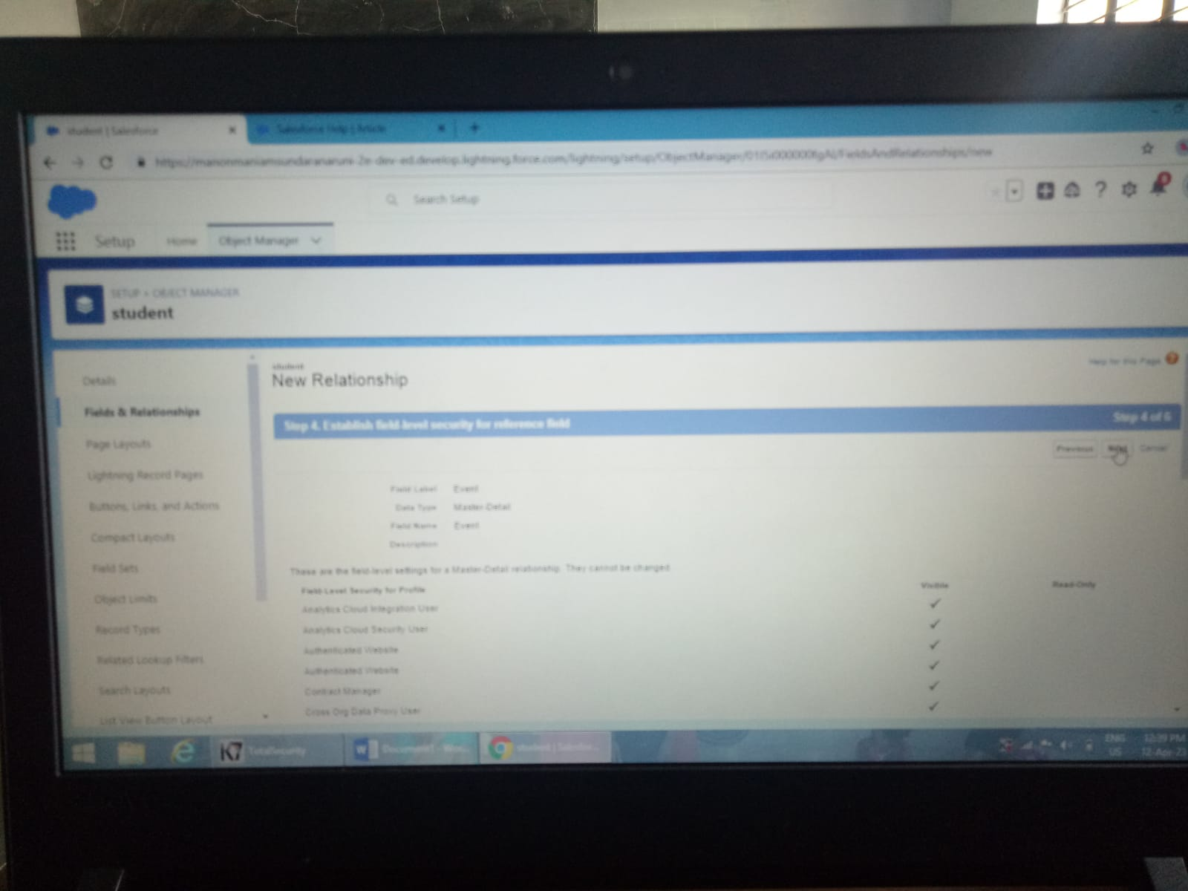

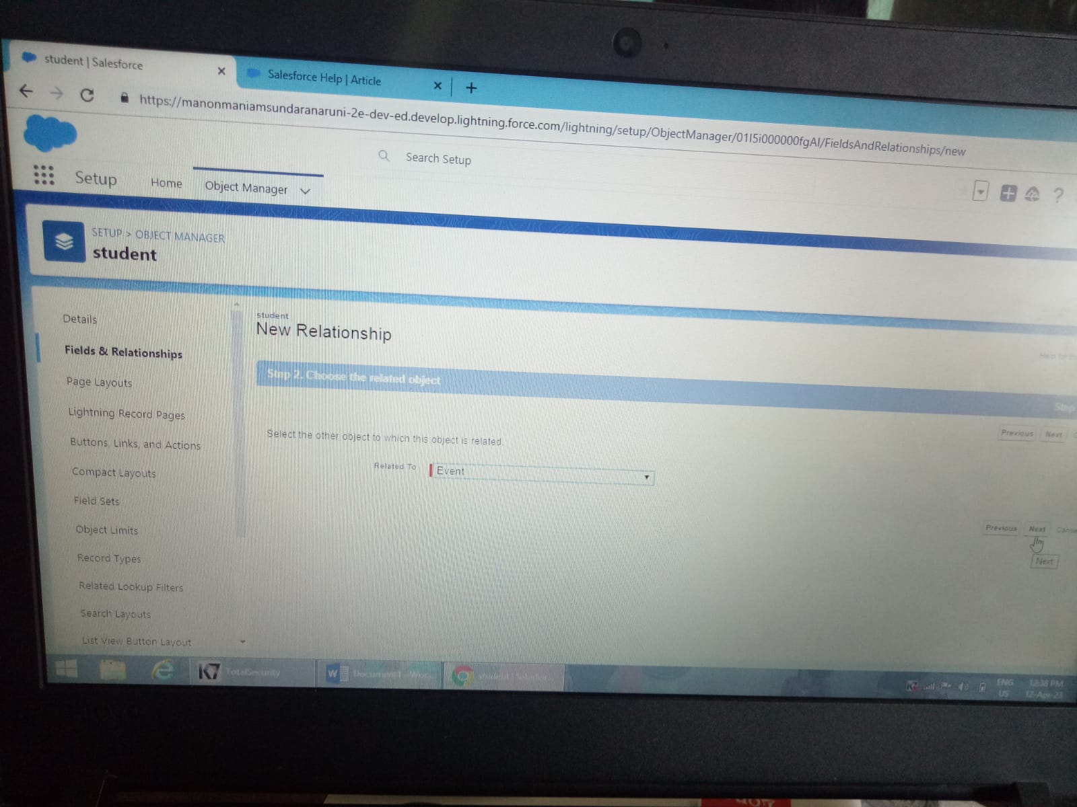

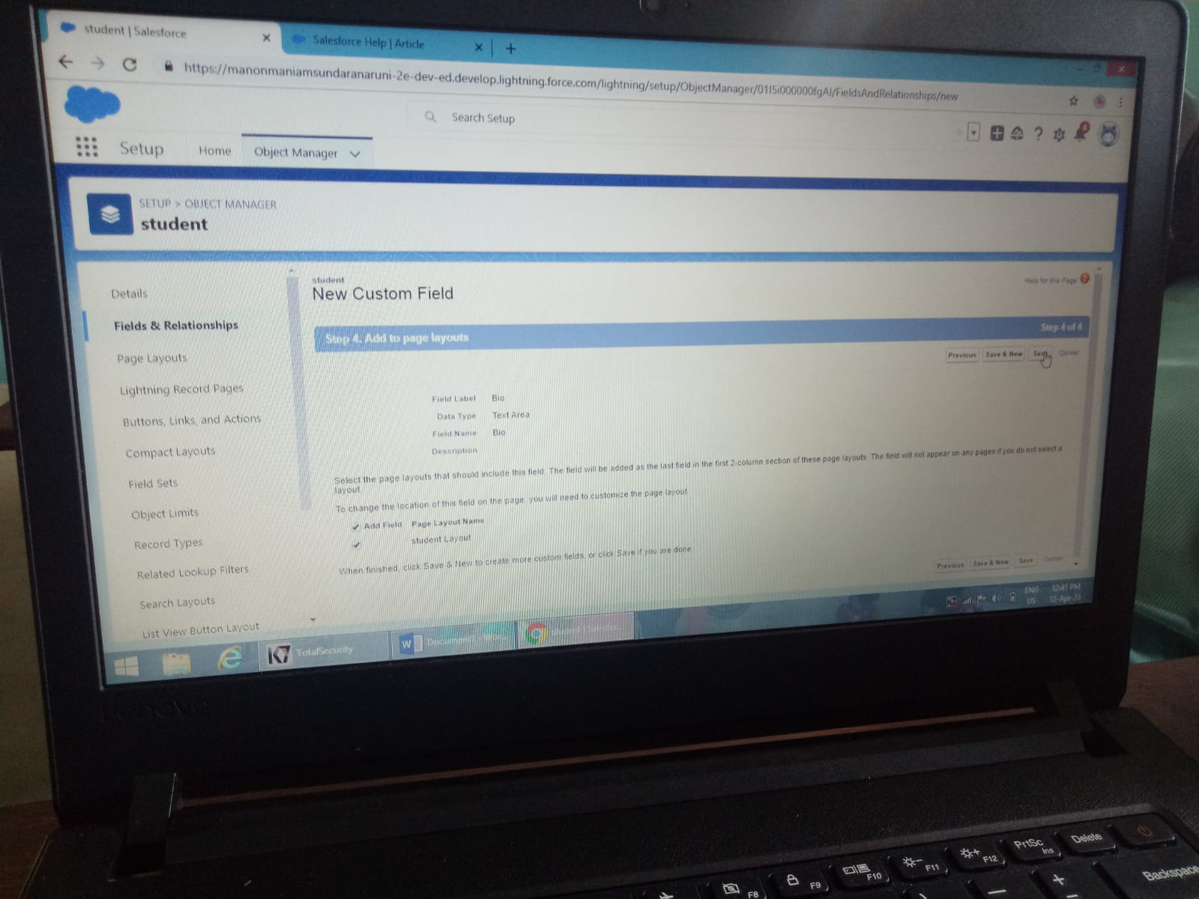





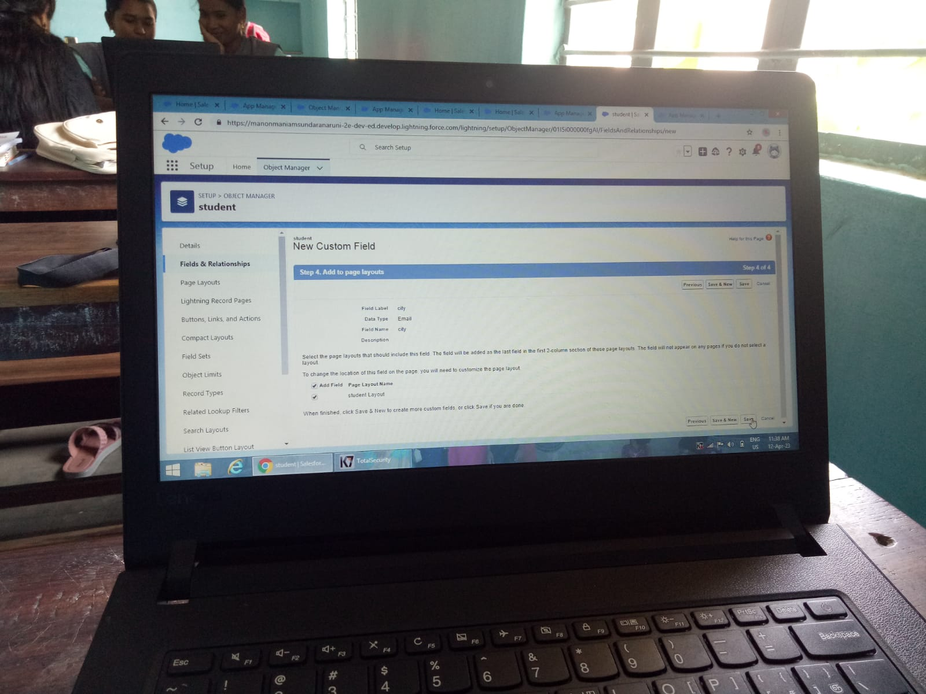

TRAILHEAD PROFILE PUBLIC URL:

Team Lead: M. MARIAMMAL – <https://trailblazer.me/id/mariammal>

Team Member: A. MUTHU LAKSHMI – <https://trailblazer.me/id/asdghjre>

Team Member: A. MUNIYASAMY - <https://trailblazer.me/id/aamuniyasamy>

Team Member: J. MARSHIYA – <https://trailblazer.me/id/jmarshiya>

ADVANTAGES:

**It’s the secret source that enables seamless integration between your sales and service organization with no complicated, costly deployments with the salesforce platform advantage everyone in your sales and service organization has a 360-degree view of every customer and their interaction with your company.**

**DISADVANTAGES:**

**Salesforce cons**

* + - **Expensive**
    - **You have to pay for add-ons to get the most out of the software.**
    - **Configuration and setup is complex and time-consuming.**
    - **Cultured interface makes navigation and simple tasks unnecessarily complex.**
    - **The learning curve never seems to end.**
    - **Customer support has a poor reputation.**

**APPLICATIONS:**

* + **Find your purpose. As with any app, you need to first of all understand what you want to build.**
  + **Consider the Implementation options.**
  + **Finalize your requirements.**
  + **Design, build, and test.**

**CONCLUSION:**

**Event Management System is user friendly with activities related to event management life-cycle. It provides a new edge to management industry. SolutionDot always keep your objectives and goals on top priority while developing any plan of work.**

**FUTURE SCOPE:**

* + **Event Management involves management, creation and development of different events like corporate events, parties, formal events etc.**
  + **The career scope in event management is immense.**
  + **Know in detail about scope of event management in India.**
  + **It involves management, creation and development of events such as corporate conferences, wedding, festivities, formal parties etc.**
  + **It involves a lot of research about the brand, target audience and the concept of the event before planning the actual event.**